Agentic AI Documentation

Natural Language to OpenStack VM Creator
This project uses Google Gemini (LLM) via LangChain and the OpenStack Python SDK to convert user natural language inputs into structured OpenStack API calls for creating virtual machines (VMs).

📌 Features
- 🧠 Natural Language Parsing with Gemini Pro 1.5
- 🔄 JSON-based intent extraction (create/delete/resize/query)
- ☁️ OpenStack API Integration for VM creation
- 🔐 Secure configuration using environment variables (.env)
- 📦 Volume-backed VM instance creation

🚀 Technologies Used
- LangChain
- Google Gemini LLM
- OpenStack SDK
- Python 3.8+
- dotenv for environment variable management
Flow

- User input: "Create a medium VM named 'db-server' with 8GB RAM
- Gemini parses it into:
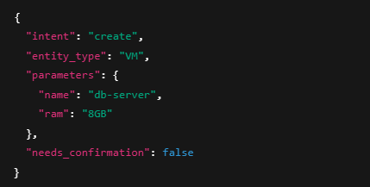
- Mapped to OpenStack, create server API with appropriate flavor, image, and network.
- A volume-backed VM instance is provisioned and confirmed.

- 🔁 FLOW OF THE create FUNCTIONALITY

✅ 1. User Input (Natural Language)
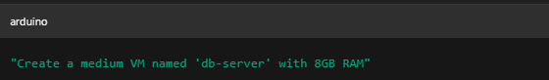

🧠 2. Function: parse_user_input(user_input)
- Purpose: Converts natural language to structured data using Gemini via LangChain.
- How: It sends the input to Gemini with a prompt template asking for:
  - intent (create/delete/etc.)
  - entity_type (VM, volume, etc.)
  - parameters (e.g., name, ram)
  - needs_confirmation (bool)
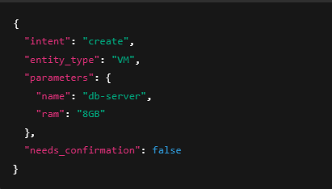

📤 3. Function: extract_json(gemini_response)
- Purpose: Cleans and parses Gemini's output to extract the JSON.
- Role: Acts as a bridge between the language model and your logic.

🔄 4. Function: map_to_openstack_actions(parsed_input)
- Purpose: Translates structured JSON into OpenStack-compatible API action.
- Only triggered if intent is create and entity is VM.
- How:
  - It checks ram to determine flavor (S.4, M.8, etc.).
  - Returns an OpenStack action dictionary.
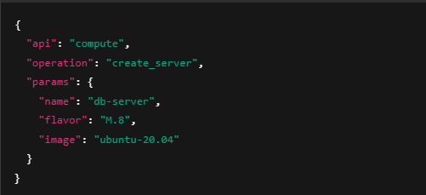

🔌 5. OpenStack Connection Setup

🛠️ 6. VM Creation
Inside create_vm():
- It creates a volume-backed instance using block_device_mapping_v2
- Waits for VM to become active.
- Prints confirmation and details.

🔁 FLOW OF THE resize FUNCTIONALITY

✅ 1. User Input (Natural Language)
"Resize the VM named 'data-node' to M.32"

🧠 2. Function: parse_user_input(user_input)
Gemini (via LangChain) extracts:
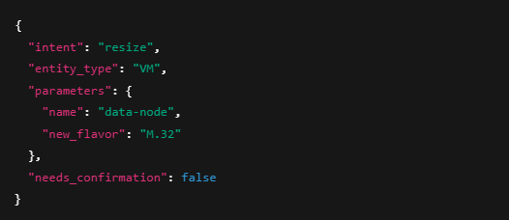

🧼 3. Function: extract_json(gemini_response)
- Parses and returns the clean JSON from the LLM output.

🔄 4. Intent Check
if intent == 'resize':

🔌 5. Function: connect_openstack()
- Authenticates with OpenStack via token.
- Returns a live connection to use for further API calls.
🔍 6. Function: find_servers_by_name(conn, vm_name)
- Searches for VM(s) matching the provided name.
- Returns a list of server objects with that name.

🚦 7. Decision Making

Case A: Single VM Found
- Resizes directly.

Case B: Multiple VMs Found
- Prompts user to choose which one to resize by index.
- Once selected, proceeds to resize.

⚙️ 8. Function: resize_vm(conn, server_id, new_flavor_id)

Steps inside:
- Get the server using ID.
- Call conn.compute.resize_server(server, new_flavor_id) to initiate resizing.
- Wait for the VM to reach "VERIFY_RESIZE" state.
- Post confirmation with:
conn.compute.post(f'servers/{server_id}/action', json={"confirmResize": None})
- VM 'data-node' resized successfully to flavor 'M.32'.

3. 🔁 FLOW OF THE delete FUNCTIONALITY

✅ 1. User Input (Natural Language)
"Delete the VM named 'test-server'"

🧠 2. Function: parse_user_input(user_input)
{
"intent": "delete",
"entity_type": "VM",
"parameters": {
"name": "test-server"
},
"needs_confirmation": false
}
🧼 3. Function: extract_json(gemini_response)
- Parses and extracts the JSON object from the language model's output.
🔄 4. Intent Handling
if intent == 'delete':

🔌 5. Function: connect_openstack()
- Authenticates with OpenStack using token.
- Returns a valid conn object used to perform operations.
🔍 6. Function: delete_vm(conn, vm_name)
Main logic:

a. Find VM(s)
servers = [server for server in conn.compute.servers() if server.name == vm_name]
- Filters all VMs with the matching name.

b. Check if Found
if not servers:
print("❌ VM not found.")
return False

c. Loop and Delete
For each matching VM:
conn.compute.delete_server(server, ignore_missing=False)
conn.compute.wait_for_delete(server)

📋 7. Final Result
If all VMs deleted:
✅ VM deleted successfully

4. 🌐 FLOW OF CREATE PRIVATE NETWORK ("BlueNet")

✅ 1. User Input (Natural Language)
"Create a private network called BlueNet"

🧠 2. Function: parse_user_input(user_input)
{
"intent": "create",
"entity_type": "network",
"parameters": {
"name": "BlueNet",
"type": "private"
},
"needs_confirmation": false
}

🧼 3. Function: extract_json(gemini_response)
- Extracts clean JSON from the LLM response.

🔄 4. Intent Handling
if intent == 'create' and entity_type == 'network':

🔌 5. Function: connect_openstack()
- Connects to OpenStack using token.
- Returns the conn object to interact with the OpenStack APIs.

🌐 6. Function: create_private_network(conn, network_name)
a. Check if Network Already Exists
existing_networks = list(conn.network.networks(name=network_name))

Prevents duplication.
- If a network with the same name exists, it prints an error and exits.
b. Create Network
network = conn.network.create_network(
name=network_name,
is_router_external=False,
shared=False
)
is_router_external=False → marks it as private.
- shared=False → not visible to other tenants.
c. Create Subnet
subnet = conn.network.create_subnet(
name=f"{network_name}_subnet",
network_id=network.id,
ip_version='4',
cidr='192.168.100.0/24',
gateway_ip='192.168.100.1',
dns_nameservers=['8.8.8.8'],
enable_dhcp=True
)
- Creates a /24 CIDR block with gateway and DNS.
- DHCP is enabled for internal IP allocation.
d. Success Message
✅ Private network 'BlueNet' and subnet created successfully.

5. 💾 FLOW OF CREATE VOLUME ("dta" disk, 100GB)

✅ 1. User Input (Natural Language)
"Create a 100 GB volume named dta disk"

🧠 2. Function: parse_user_input(user_input)
{
"intent": "create",
"entity_type": "volume",
"parameters": {
"name": "dta disk",
"size": 100
},
"needs_confirmation": false
}

🧼 3. Function: extract_json(gemini_response)
- Extracts valid JSON for downstream use.

🧠 4. Intent Check
if entity == "volume" and intent == "create":

🔌 5. Function: connect_openstack()
- Establishes a connection with OpenStack using token-based authentication.
- Verifies with conn.authorize().
- Returns a conn object.

💽 6. Function: create_volume(conn, volume_name, size_gb)
a. Log the Operation
print(f"💾 Creating volume '{volume_name}' of size {size_gb} GB...")

b. Create the Volume
volume = conn.block_storage.create_volume(name=volume_name, size=size_gb)

c. Wait for Completion
conn.block_storage.wait_for_status(volume, status='available', failures=['error'], interval=5, wait=300)

d. Print Success
print(f"✅ Volume '{volume_name}' created successfully with ID: {volume.id}")

5. 💾 FLOW OF CREATE VOLUME ("dta" disk, 100GB).

✅ 1. User Input (Natural Language)
"What's my project usage?"

🧠 2. Function: parse_user_input(user_input)
{
"intent": "query",
"entity_type": "project_usage",
"parameters": {},
"needs_confirmation": false
}

🧼 3. Function: extract_json(gemini_response)
Extracts valid JSON used in routing logic.

🧠 4. Intent Check

if intent == "query":

🔌 5. Function: connect_openstack()
- Uses token to authenticate via OpenStack API.
- Returns conn if successful.

📦 6. Function: get_project_usage(conn)
a. Fetch All Servers
servers = list(conn.compute.servers(all_projects=False))

b. Initialize Totals
total_vcpus = 0
total_ram_mb = 0
total_gpus = 0

c. Loop Over Each Server
- Get flavor ID → fetch flavor → read vcpus, ram
- Try to extract resources:VGPU from extra_specs
flavor = conn.compute.get_flavor(flavor_id)
extra_specs = flavor.extra_specs
gpu_count = int(extra_specs.get('resources:VGPU', 0))
d. Aggregate Volume Usage
volumes = list(conn.block_storage.volumes(details=True))
total_volume_gb = sum(volume.size for volume in volumes if volume.status in ['available', 'in-use'])

e. Print the Summary
print(f"✅ Usage Summary:")
print(f" - Total vCPUs: {total_vcpus}")
print(f" - Total RAM (MB): {total_ram_mb}")
print(f" - Total GPUs: {total_gpus}")
print(f" - Total Volume Size (GB): {total_volume_gb}")

f. Return Results

return {
"vcpus": total_vcpus,
"ram_mb": total_ram_mb,
"gpus": total_gpus,
"volume_gb": total_volume_gb
}

